Name : GOKUL BARADWAJ C
REG. NO. : 192512073
Experiment Number: 1
Simulation and Comparative Analysis of FDMA, TDMA and CDMA:
Resource Allocation, User Capacity and Mobile-Generation Context

OUTPUT :

OBJECTIVE 1:

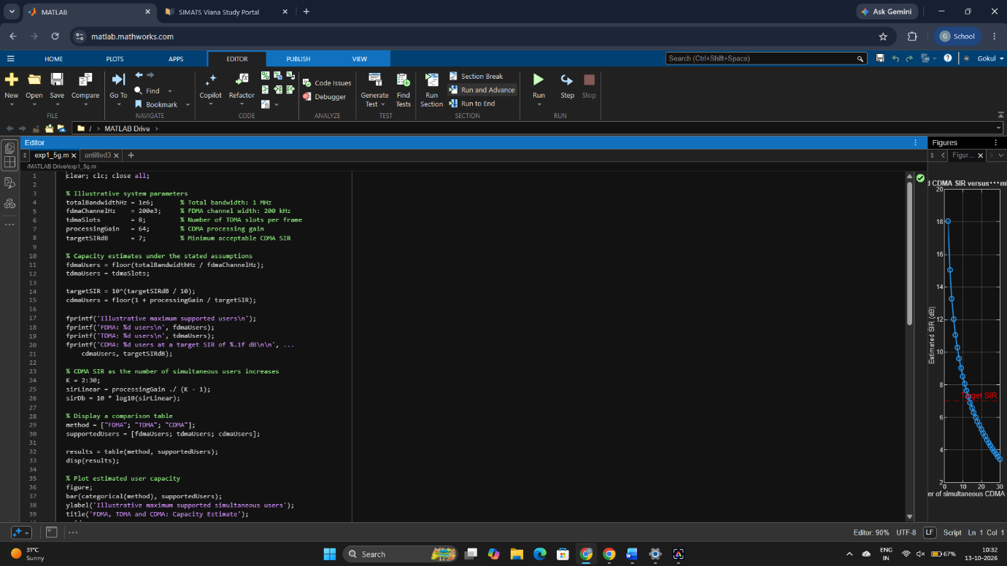

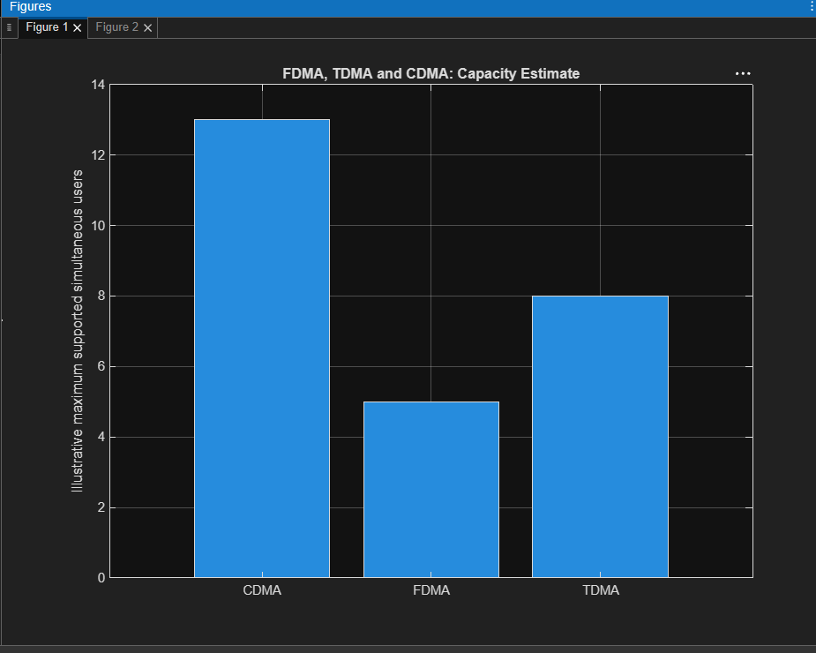
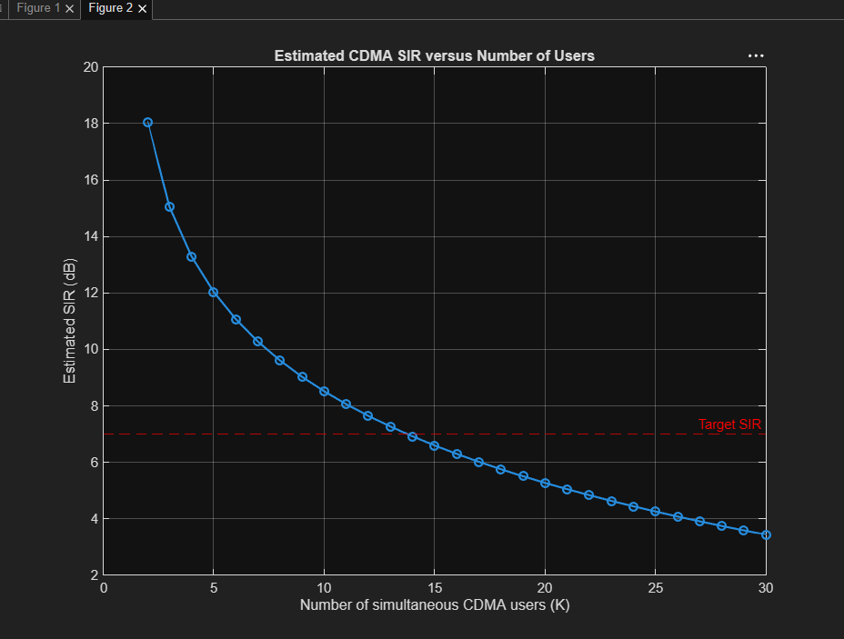

OBJECTIVE 2 :
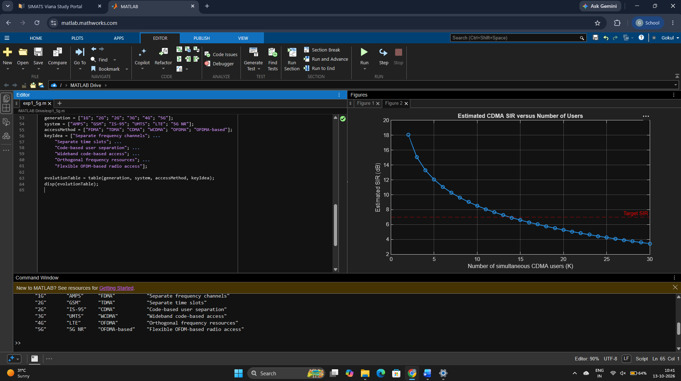

OBJECTIVE 3 :

